Student Task Management System

A PROJECT REPORT

Submitted by
Shalini Pandurang Shanbhag - 1BM24MC086
in partial fulfillment for the award of the degree of Master of Computer Applications
Under the guidance of

Internal Guide | External Guide
Dr. D. N. Sujatha  Professor  Dept. of Computer Applications  B. M. S. College of Engineering  Bangalore-560019 | Mr. Ramkumar  Manager  Nyera Edutech & Innovations Pvt Ltd.  Bangalore-560001



B. M. S. COLLEGE OF ENGINEERING BANGALORE-19
JUNE -2026

B.M.S. COLLEGE OF ENGINEERING
(Autonomous College under VTU, Approved by AICTE, Accredited by NAAC)

MASTER OF COMPUTER APPLICATIONS

This is to certify that Shalini Pandurang Shanbhag[1BM24MC086] has satisfactorily completed the requirements for Major Project - MMCPRJ401 entitled “Student Task Management System” as a part of the 4th Semester MCA course in this college during the year 2025.

Internal Guide

…………………………….

External Guide

………………………….

Dr. D. N. Sujatha  Professor  Dept. of Computer Applications  B. M. S. College of Engineering  Bangalore-560019 | Mr. Ramkumar  Manager  Nyera Edutech &  Innovations Pvt Ltd.  Bangalore-560001

Head of the Department Principal

…………………………….. ………………………….
Dr. S Uma Dr. Bheemsha Arya
Professor and Head, Dept. of CA Principal,
Dept. of Computer Applications B.M.S. College of Engineering
B.M.S. College of Engineering Bangalore-560019 Bangalore- 560019

………………………….. …………………………
Examiner 1 Examiner 2

DECLARATION

I hereby declare that this project entitled “Student Task Management System” carried out at “Nyera Edutech & Innovations Pvt Ltd” is a record of project work submitted to the Department of Computer Applications, B.M.S College of Engineering, affiliated to Visvesvaraya Technological University is an original work completed by me.

To the best of my knowledge, this report has not been submitted to any other college or university or published at any time prior to this.

Date: Name: Shalini Pandurang Shanbhag
Place: Bangalore USN: 1BM24MC086

ACKNOWLEDGEMENT

No achievement is possible without the help, support, and guidance of inspirational students and this project is incomplete without an acknowledgment of the gratitude of these individuals. Each one of them has contributed in their own unique and invaluable way to the undertaking of this project.

I take this opportunity to thank all the students who have been supportive throughout this report.

First, I would like to thank my external guide Mr. Ramkumar, Manager of Nyera Edutech & Innovations Pvt Ltd. Who has been a constant support in the process of completing my Internship.

Second, I would like to thank my internal guide Dr. D. N. Sujatha, Professor, Department of Computer Applications, for his constant support and guidance in preparing this report.

Next, I would like to thank my Head of the Department Dr. S Uma for her guidance and support.

I also wish to place my deep debt of gratitude to Dr. Bheemsha Arya, Principal, B. M. S. College of Engineering for his constant help.

I would also like to thank my parents and friends for their support and guidance.

Shalini Pandurang Shanbhag USN: 1BM24MC086

ABSTRACT

The project titled “Student Task Management System” is built as a modern web-based application called Tasklytics, developed to help students efficiently organize tasks, monitor different activities, and analyze their overall performance through an interactive dashboard. Today, there is a great need among students for the existence of an intelligent assignment management platform where users could efficiently manage their projects, deadline, exams and everyday schedule. However, traditional platforms like notebooks, spreadsheets, or reminders do not provide adequate support in terms of analysis, real-time monitoring, and evaluation of the user's performance. This project addresses all these issues and offers an efficient solution that ensures security and accessibility of data in a cloud storage.
Users of the system can easily register and sign into their accounts using appropriate authorization tools. Students will be able to create, edit, classify, prioritize, schedule, and track their daily tasks based on their deadlines, required time to complete them, and status of execution. In addition, productivity analysis becomes possible for students as they are offered a series of dashboard views allowing analyzing completed, pending, overdue, and categorized tasks.
The suggested solution uses modern technologies and implements a modular and scalable software architecture that enables introducing some improvements in the future, including implementing AI-driven recommendation algorithms, developing the mobile app, integrating the tool with calendars, scheduling reminders and collaborating with other students in tasks.
The “Student Task Management System” not only simplifies student task management but also provides meaningful productivity insights that assist students in improving efficiency, reducing missed deadlines, and achieving better student performance.

TABLE OF CONTENTS
Table of Contents
1. INTRODUCTION 1
1.1 Project Description 1
1.2 Motivation 3
1.3 Existing and Proposed System 4
1.4 Hardware and Software Requirements 6
2. SYSTEM ANALYSIS 8
2.1 Feasibility Study 8
3. PROJECT PLAN 11
3.1 Gantt Chart 13
4. SOFTWARE REQUIREMENTS SPECIFICATIONS (SRS) 14
4.1 Introduction 14
4.1.1 Purpose 14
4.1.2 Product Scope 14
4.2 Overall Description 14
4.3 External Interface Requirements 16
4.3.1 User Interfaces 16
4.3.2 Software Interfaces 17
4.3.3 Communications Interfaces 17
4.4 System Features and Functional Requirements 17
4.4.1 User Management 17
4.4.2 Task Management 18
4.4.3 Subtask Management 18
4.4.4 AI-Powered Task Breakdown 18
4.4.5 Daily Planner 19
4.4.6 Eisenhower Matrix 19
4.4.7 Productivity Analytics and Heatmap 19
4.4.8 Automated Email Reminders 19
4.4.9 Settings and Account Management 20
4.5 Non-Functional Requirements 20
4.5.1 Performance 20
4.5.2 Safety 20
4.5.3 Security 20
4.5.4 Software Quality Attributes 21
4.5.5 Business Rules 21
4.6 Additional Requirements 21
4.6.1 Database 21
4.6.2 Legal and Compliance 22
5. SYSTEM DESIGN 23
5.1 Class Diagram 23
5.2 Use Case Diagram 25
6. IMPLEMENTATION 26
6.1 Technology Used 26
6.2 Screenshots 29
7. TESTING 34
7.1 User Registration and Login Module 34
7.2 Task Management Module 35
7.3 Subtask and AI Breakdown Module 36
7.4 Daily Planner Module 36
7.5 Analytics and Heatmap Module 37
7.6 User Profile and Settings Module 37
7.7 Summary of Test Results 38
8. IMPACT ON SOCIETY AND ENVIRONMENT 39
8.1 Impact on Society 39
8.2 Impact on Environment 39
8.3 Sustainable Development Goals (SDGs) 40
9. CONCLUSION 42
10. FUTURE ENHANCEMENTS 43
11. BIBLIOGRAPHY 45

LIST OF TABLES

Table 1 Hardware Specification for developing Tasklyics 6
Table 2 Software Specification for developing Tasklyics 7
Table 3 User Classes and Characteristics description of Tasklytics 15
Table 4 External Software Interfaces for Tasklytics 17
Table 5 Quality Attributes of the Tasklytics System 21
Table 6 Test Cases for User Registration and Login Module of Tasklyics 34
Table 7 Test Cases for Task Management Module of Tasklyics 35
Table 8 Test Cases for Subtask and AI Breakdown Module of Tasklyics 36
Table 9 Test Cases for Daily Planner Module of Tasklyics 36
Table 10 Test Cases for Analytics and Heatmap Module of Tasklyics 37
Table 11 Test Cases for User Profile and Settings Module 37

LIST OF FIGURES

Figure 1 Gantt Chart For Tasklytics 11
Figure 2 Class Diagram for Tasklyics 17
Figure 3 System Use Case Diagram for Tasklytics 19
Figure 4 Analytics Page in Tasklytics-1 22
Figure 5 Anylitics Page in Tasklytics-2 23
Figure 6 Dashboard of Tasklytics 23
Figure 7 Task Planner in Tasklytics 24
Figure 8 Prioritization Matrix in Tasklytics 25
Figure 9 Task Manager in Tasklytics 25
Figure 10 Page of Task Book Eye Checkup Appointment 26
Figure 11 Settings Page in Tasklyics 27
Figure 12 Add New Task Page in Tasklyics 27

INTRODUCTION
In today's technologically-driven world, managing tasks and ensuring personal productivity is becoming increasingly relevant. Individuals of all kinds including students, employees, freelancers, and even teams find it difficult to manage their tasks, allocate resources, and stay productive. Existing task management applications offer simple functionality such as creating tasks, assigning deadlines and statuses. These capabilities are quite handy yet do not provide an intelligent way for improving task management.
Today, students tend to balance many things in parallel. There are always many different deadlines and priorities that need to be considered. In addition, students tend to set personal goals. Thus, it is difficult to manage such a complex combination manually as it might cause inefficiencies, problems with deadline achievement, low productivity, and increased stress. What students actually need is a sophisticated solution that will not only monitor tasks but also provide analytics and suggestions.
Tasklytics offers a solution to these issues through the integration of task management and productivity monitoring functionality with analytical and visualization capabilities.
The Priority Matrix is one of the most valuable features of Tasklytics, which allows the users to categorize the tasks based on their urgency and importance. Thus, with this tool, it will be possible for users to devote their time to priority tasks and, at the same time, manage other tasks effectively. Besides, this system has a Pomodoro timer, which promotes concentration when working.
To get some valuable insights into users' productivity, Tasklytics has a feature called activity heatmap similar to the one found in GitHub. The users will be able to determine what times of day they are the most productive and monitor their consistency in completing tasks. Also, there are such status options for tasks as Open, In Progress, Blocked, Completed, and Overdue to monitor their progress.
On the whole, with Tasklytics, users will be able to manage tasks, track their productivity, monitor performance, and even improve their own organizational skills. As for such features as task management, task prioritization, focus during work, and analysis of user's progress with the help of visualizations, they make Tasklytics an effective productivity tool.

1.1 Project Description

This project was undertaken at Nyeras (NYERAS Edu-tech and Innovations Pvt. Ltd.), an online educational platform focused on career acceleration and skill enhancement.
The goal of developing this task management system is to create an intelligent, responsive, and scalable web application that would allow students to register themselves and perform various operations such as authentication, management of tasks, tracking of progress, and generation of subtasks using artificial intelligence. This system was developed using the JavaScript full stack, which consists of Node.js, Express.js, React.js (using Vite), and MySQL.
The platform incorporates essential student productivity features including user authentication and profile management, task and subtask creation with CRUD operations, AI-powered task breakdown using Google Gemini 2.5 Flash, a daily planner view, an Eisenhower priority matrix, productivity analytics with a heatmap grid, and automated deadline reminders. An AI controller was also built to interface with the Gemini API, generating 4 to 6 actionable, time-estimated subtasks per assignment along with a personalised success strategy — providing students with structured guidance beyond a simple to-do list. React.js was used in front end development due to its ability to offer a component based framework and render content dynamically. The frontend also had a neat and responsive user interface that ensured better usability of the application.
Backend technology was selected based on Node.js and Express.js to ensure non-blocking server performance. MySQL was used in database design and is interfaced through the mysql2 driver for data handling. The routes are categorized by domains, including user, task, analytics, and AI, all of which are handled by a middleware layer that provides authentication through JWT. APIs were designed in line with the REST approach to provide modularity and maintenance ease. The project had a scheduled background process using the node-cron package which runs daily in the morning to determine tasks to be done tomorrow.
This project has provided practical training in web development. Apart from deepening knowledge in full-stack development, the project has offered exposure to software development practices like modular programming, authentication, API designing with large language models, database designing, and user interface/user experience design. Participation in this project provided improvement in problem-solving skills and effective time management, important for professional software development

1.2 Motivation

Indeed, the swift advancement of technology in student work has revolutionized the way students approach organization, planning, and execution of tasks. Intelligent technologies are becoming ever more prominent. As such, student task management systems require development to ensure user-friendliness and technological innovation. Tasklytic, therefore, can be seen as a result of such conceptualization and development. Technically speaking, a major reason for the need to develop the project includes the creation of a web application that was responsive, secure, scalable, and modular using the latest full-stack development technology stack. Full-stack JavaScript-based solutions are becoming increasingly popular because they provide full development capabilities and can serve the development process very well. The following four technologies make up the selected full stack:
• React.js (Vite) – A highly useful library for creating interactive and dynamic frontends.
• Node.js – A runtime environment that allows developing robust server-side solutions.
• Express.js – A minimalistic web application framework designed specifically for Node.js.
• MySQL – A dependable and efficient relational database management system.

The following were some of the challenges that motivated the choice of the selected technology and design approaches in Tasklytic.
- Scalability and Structured Data Handling
Using MySQL with the mysql2 driver enables Tasklytic to efficiently manage an increasing amount of structured data ranging from user accounts, tasks, subtasks, logs, and heatmap activities. The use of relational tables ensures consistency among connected objects while capturing information such as multiple subtasks contained within a task, with each having its status and estimation period.

- Performance and User Interface Efficiency
React provides a high-performance interface that is able to update sections of the interface without the need to re-render the whole page when a student uses components such as task manager, daily planner, Eisenhower matrix, and analysis dashboard. The use of React components also makes it easy to write reusable code by using pages such as Task Detail, Dashboard, and Analysis.

3. Security and User Authentication
Using Express.js and Node.js for the backend, the platform enjoys strong routing and middleware capabilities. User authentication and secure sessions have been facilitated by implementing JWT (JSON Web Tokens), which allows for secure routes, encryption during client-server interaction, and safe processing of sensitive user information such as passwords and security questions. Password recovery and resetting functionalities have been implemented using Nodemailer for comprehensive account protection.

4. AI Integration and Intelligent Extensibility
The main inspiration for designing Tasklytic involved the integration of a generative artificial intelligence component within the student workflow. The Google Gemini 2.5 Flash API was built into the task cycle to automatically break down any assignment into 4 to 6 subtasks with estimations of time and effort, alongside offering a customized success plan. The example above highlights the extensible nature of the modular Node.js framework, providing for seamless integration with external AI services.

5. Automation and Proactive Notifications
The system makes use of node-cron to schedule background processes that find tasks to be performed on the next day and sends the users automated rich HTML formatted reminder emails via Nodemailer. With this automation in place, no task will ever be missed due to lack of awareness as there is zero need for manual effort to send such notifications.

6. Developer Productivity and Maintainability
With a consistent JavaScript stack implemented in both front and back ends, this project enjoys better development productivity as developers do not require switching contexts between different languages. The routes have been segregated based on the type of data they handle, including user, task, analytics, and AI with their own controllers and services as part of a clear modular structure.

1.3 Existing and Proposed System

Current systems that manage tasks in students' workflows consist of universal productivity software like Microsoft To-Do, Notion, Google Tasks, or Trello. These apps allow users to perform essential functions like creating new tasks, assigning deadlines to them, and tracking their progress to some extent. Nevertheless, they do not include any functionality that is specifically designed for students. For example, they do not have features related to intelligent task decomposition, categorization, estimating study efforts, or generating reminders based on deadlines. Current solutions have an ordinary template without any customization possibilities and, consequently, lower student engagement and productivity.

1.3.1 Disadvantages of Existing System

- Generic systems are not tailored for student purposes and do not have features like task categorization, estimating subtasks' time requirements.
- AI integration is missing in most tools, and students are required to perform a task breakdown manually.
- Productivity data analysis, including completion heatmap, effort level, and workload balance chart creation, is not implemented in free version apps.
- Automated reminder of deadlines is either absent from systems or should be set up manually via third-party integration services.
- The concept of priority organization, for example, via Eisenhower Matrix, cannot be realized due to lack of relevant tools.
- Planner for each day dedicated to specific courses subtasks' organization is not provided.
- Information is scattered across separate applications, which reduces consistency of productivity system of a student.

Proposed System
The new system will be referred to as Tasklytic and is a purpose-built intelligent AI-powered student task management system that will address students' specific coursework, assignment, and schedule management needs. As opposed to common productivity tools like Notion or Trello, which do not have an student-oriented interface, this system will be built in such a way as to be both useful and intelligent, as well as to emphasize task structuring, AI guidance, and automation. The software has been implemented using a modern JavaScript full stack, including React.js (Vite), Node.js, Express.js, and MySQL technologies.
Tasklytic was conceived with three main objectives in mind. First, a system was required that would allow all the student tasks and their subtasks to be created and tracked from a single place. Second, an integration of the Google Gemini AI technology needed to be performed to facilitate the splitting of assignments into subtasks with estimated time and unique study approaches for each of them. Finally, the system should enhance the users' level of involvement and consistency through the use of various elements like productivity heatmaps, daily planners, Eisenhower matrices, and reminders.
The advantages of meeting these goals will be substantial compared to other software products. The platform offers student-specific experience with its own customized interface, course-wise organization of content, and artificial intelligence-based recommendations related to the workflow of students. Task segmentation through the power of Google Gemini AI will ensure the breaking down of each task into four to six smaller actions with their respective deadlines and strategies for completing them, minimizing the burden on students to the minimum. Notifications for deadlines will be done using the Cron-based email alert system that sends notifications to the users the previous day when their respective tasks are due without any intervention from the user side. .
To deliver on these objectives and advantages, Tasklytic is built around the following core features:
- Sign-up/Login: Sign-up process incorporating JWT, encryption of the user password using bcrypt, and forgot password implementation with Nodemailer.
- Task/Subtask Management: Complete task management with features like create, read, update, and delete for tasks. Support for title, description, category, due date, priority and status of the student tasks.
- AI-Based Task Splitting: Google Gemini 2.5 Flash to extract structured subtasks from the input task, time estimation of completing the subtasks, effort level required for the subtask and study tip personalized to the task.
- Daily Task Planner: View subtasks that are due today. Helps students focus on their immediate work.
- Eisenhower Matrix: Priority matrix based on the task's urgency and importance. Makes the task selection a conscious process.
- Productivity Metrics & Heat Map: Visualization of completion rates, percentage of tasks completed from each category, and activity chart similar to Github commit trend.
- Tasks Reminder Emails: Background job using node-cron package sends email reminders of tasks that are due tomorrow, automatically.
- User Settings: Option for the user to update their profile information, passwords and security questions from settings tab.

1.4 Hardware and Software Requirements

    - Hardware Specification
Table 1 Hardware Specification for developing Tasklyics
Component | Specification
Processor (CPU) | Intel Core i5 / i7
RAM | Minimum 8 GB
Storage | 256 GB SSD
Operating System | Windows 10 / 11
Network | Stable broadband internet connection (≥ 20 Mbps)

Software Specification
Table 2 Software Specification for developing Tasklyics
Category | Software / Technology (with Version)
Frontend | React.js v19.x (Vite 5.x build tool)
 | JavaScript ES2022
 | HTML5, CSS3
 | React Router DOM v7.x
Backend | Node.js v18.17.1
 | Express.js v5.2.1
Database | MySQL v8.0+ (with mysql2 v3.x driver)
ORM / Query | mysql2 with connection pooling
Authentication | JSON Web Token (JWT) v9.0.x + bcrypt v6.x
AI Integration | Google Gemini 2.5 Flash API (@google/generative-ai v0.24.1)
Email Service | Nodemailer v8.x
Scheduler | node-cron v4.x
Code Editor | Visual Studio Code v1.90.0
Version Control | Git v2.43.0 + GitHub
Web Server | Node.js Server with Express Middleware
Operating System | Windows 10 / 11
Browser  Compatibility | Google Chrome v138.0.7204, Mozilla Firefox v140.0, Microsoft Edge  v138.0.3351.65, Safari v18.5

SYSTEM ANALYSIS

2.1 Feasibility Study
Feasibility analysis plays a crucial role in assessing the viability of a project in terms of design, development, and implementation. The feasibility analysis of Tasklytic — an intelligent task management system for students that leverages AI — has been performed from four different perspectives: technical feasibility, operational feasibility, economic feasibility, and scheduling feasibility.
2.1.1 Technical Feasibility
The proposed Tasklytic solution is feasible from a technical perspective because the suggested solution leverages modern JavaScript full stack technologies such as React.js (Vite), Node.js, Express.js, and MySQL. All these technologies are not only free to use, but they are open-source, popular, and widely implemented in practice.
MySQL paired with the mysql2 driver offers structured and relational database storage of user, task, subtask, analytics logs, and heatmap activities. The database's relational schema helps in maintaining data consistency between entities and provides complex querying for analysis and scheduled jobs. In the backend side, Node.js paired with Express.js is used, which provides a lightweight and highly efficient runtime environment together with a solid web application framework for processing API routes, implementing middleware, scheduling jobs, and server functionality. For creating the front end part of the application, React.js is used together with the Vite build tool, which allows constructing the front end part in a more efficient way while ensuring that all the features of React.js are utilized. One of the major benefits of the proposed software stack is the ability to code all parts of the application in one programming language, namely, JavaScript. Moreover, the system makes use of external third-party libraries implementing various useful functionalities, including JSON Web Token-based authentication, hashing passwords with bcrypt, sending emails with Nodemailer, background job scheduling with node-cron, and task decomposition with the help of Google Gemini 2.5 Flash API. Considering the aforementioned factors, the application is entirely ready for performance.
2.1.2 Operational Feasibility
In terms of feasibility, the system is very feasible because it provides an effective and convenient way for students to manage their academic assignments. They are able to sign up for an account, log in securely, organize their assignments based on course categories, get an automatic breakdown of each assignment into subtasks using artificial intelligence, monitor their progress using the planner, and receive automatic emails reminding them about upcoming deadlines.
With the help of AI integration through Google Gemini, planning your assignments will be much easier since you will automatically get a detailed plan. With secure JWT authentication, users will be able to protect their information, as there will be bcrypt encrypted passwords and a possibility to reset passwords using emails. The use of the Eisenhower Matrix and Productivity Heat Map will provide students with a tool that will help them prioritize their activities and assess their study discipline without the need to depend on any external tool like an Excel spread sheet or other similar software to track their performance. In addition, the automated cron job based emailing system works automatically and sends out all deadline reminders without any involvement at all from the student. Lastly, the settings page enables students to control everything about themselves independently.
2.1.3 Economic Feasibility
The solution is economically feasible, and hence affordable, which makes it ideal for individual students and educational institutions. It involves the use of all open-source solutions, thus, avoiding the costs associated with using expensive proprietary software and licenses. MySQL databases can be deployed on various free-tier cloud computing databases, while the frontend and backend can be initially launched on various platforms such as Vercel at zero cost, and then scaled later depending on the traffic.
It involves the use of a free tier in Google Gemini API, which is adequate for development and even moderate production purposes. With regard to the cost-effectiveness of the design, the implementation involves the use of a modular codebase in which controllers, services, and routes are easily identifiable and thus easily updatable or replaceable in the future. The use of free-tier email service providers and Nodemailer ensures that there are no costs associated with the use of transactional emails in the early stages of deployment. All in all, the automated tasks, analytics, and AI features eliminate the need for expensive tutoring or subscription plans.
2.1.4 Scheduling Feasibility
The project development process utilized the Agile methodology, which is a flexible and iterative project management methodology that emphasizes rapid delivery and iterative planning. The use of the Agile development methodology allowed for an efficient development process, as well as a systematic approach to each development stage. The development process included several stages, each of which involved different processes, including requirement gathering – user stories, technical specification, and prioritization; UI/UX design – page wireframe development.
Back-end development included the creation of the modular architecture of the application that includes user authentication, task/subtask management, integration of AI technology, analytics, and scheduling emails. Meanwhile, front-end development involved making sure that all pages are responsive and integrated with back-end services via RESTful API. Sprint cycles were implemented during each module development. Each sprint cycle included different modules, such as user registration/login, task management CRUD operations, AI tasks breakdown, daily planner, Eisenhower matrix, heatmap analytics, and scheduling email services.
The use of GitHub enabled version control via proper code management using techniques such as branches, pull requests, and commit messages. The code was reviewed at regular intervals to make sure that its quality was up to the mark. Both unit testing and integration testing were performed in each sprint in order to test the functioning of all modules. The documentation of software development process was done at the same time, which included the documentation of APIs and procedures for software deployment. The project could be successfully developed within the proposed timeframe because of proper management of time, proper division of work into modules, and the use of Agile approach.

PROJECT PLAN

Project planning is a fundamental component of SDLC as it comprises goal-setting, requirement gathering, resource allocation, time estimation, and project activity organization. An effective project plan can be used as a development strategy that helps complete the project in an optimal manner to ensure compliance with all functional and quality requirements.

Tasklytics was created through the application of a structured and iterative methodology that entailed requirement analysis, system designing, programming, testing, and deployment. The development process had a number of different phases during which specific objectives were achieved. By dividing the process into phases, the project could be more manageable and monitored for its progress.

The initial steps in the planning stage involved the determination of the difficulties experienced by users when organizing their tasks, staying productive, and prioritizing responsibilities. Requirement analysis was carried out based on the assessment of current productivity tools along with the identification of such essential features as task tracking, prioritization, productivity visualization, and focused tasks. As per the analysis results, appropriate technologies were chosen for the frontend, backend, database management, and analytics features.

The process of developing Tasklytic was carried out systematically through various phases.

Phase 1: Requirement Analysis (Week 1-2)
Requirements along with project goals were defined as well as features, roles of users, and priority order. This phase was the basis for all other development tasks.

Phase 2: UI/UX Design (Week 3-4)
Wireframes and mockups were made for each of the main pages such as Dashboard, task detail page, daily planner, Eisenhower matrix, and analytics. Finally, design guidelines including color schemes, fonts, and layout structure were determined.

Phase 3: Environment Setup (Week 5)
Environment was prepared by installing React (Vite), Node.js, Express.js, MySQL for backend, and initialising a GitHub repository for version control purposes. Database was established locally to develop simultaneously both backend and frontend.

Phase 4: Backend Development (Week 6-9)
RESTful APIs were implemented using Express.js for performing tasks related to user registration, tasks and subtasks operations, generation of analytics information, and implementing AI. MySQL schemes and JWT, bcrypt algorithms for passwords security and emailing services via Nodemailer were introduced.

Phase 5: Frontend Development (Week 10-13)
React.js was used for frontend implementation together with Vite. Page navigation was implemented using React Router, and components were created to reuse them in different parts of application.

Phase 6: AI Integration Module (Weeks 12–13)
The controller was created to connect to the Google Gemini 2.5 Flash API to automatically decompose tasks to 4–6 subtasks with estimates of duration and effort classification. An AI-unavailable scenario was accounted for in the design as a fallback option.

Phase 7: Testing & Debugging (Weeks 14–15)
The testing of the product, including unit, integration, API, and UI/UX testing was performed. All bugs in terms of handling data, using cron jobs, and parsing from API were detected and fixed.

Phase 8: Deployment & Hosting (Week 16)
The backend and frontend products were deployed on Vercel with cloud-based database MySQL server. All environment variables, keys to API, and production mode were checked.

Phase 9: Documentation & Report (Weeks 16–17)
This phase includes finishing the project report and user manual. It is done simultaneously with deployment for efficiency in the time left before the deadline.

Phase 10: Final Presentation Preparation (Week 18)
This week will be dedicated to preparing the presentation, live demo, and ensuring viva readiness by thoroughly checking all systems.

3.1 Gantt Chart
Below is the Gantt chart representing the schedule of development phases over an 18-week period, showcasing task sequencing and parallelism of activities and their dependencies.
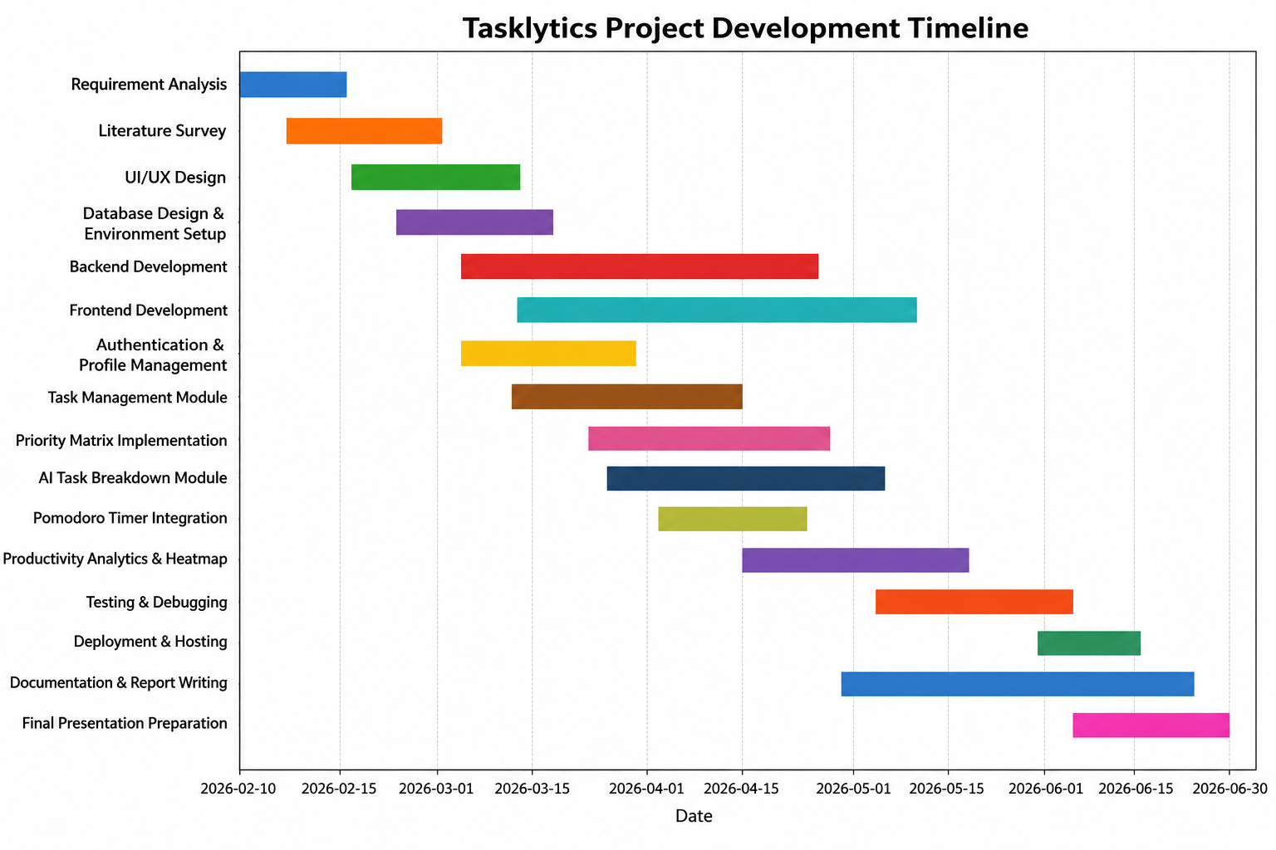
Figure 1 Gantt chart development timeline of Tasklytic

Figure 4.1 represents the timeline of the evolution of the Tasklytics application throughout four months starting from 10 February till June. During that period, the application evolved in several phases which include requirements analysis, literature review, UI/UX Design, Database design and environment setup, Backend and Frontend development, Implementation of Priority Matrix & AI Task Breakdown Module, Pomodoro timer and finally Productivity Analytics through activity heatmap similar to Github.

In accordance with the timeline represented by Figure 4.1, there are some activities performed at the same time to make development more efficient. Core development includes implementation of backend services, frontend development, authentication mechanism as well as task management. In addition to that, advanced productivity features such as AI Task Breakdown Module, Priority Matrix, Pomodoro Timer as well as productivity analytics were implemented in later development phases.

SOFTWARE REQUIREMENTS SPECIFICATIONS (SRS)

4.1 Introduction

4.1.1 Purpose
This Software Requirements Specification describes the complete set of functional and non-functional requirements for the AI-Powered Student Task Management System, Version 1.0. The system is a full-stack web application designed to reduce the cognitive burden on students by bringing task organisation, AI-assisted planning, and productivity monitoring together in one cohesive platform.
The application is built on a React frontend, a Node.js/Express.js backend, a MySQL relational database, and the Google Gemini 2.5 Flash API for AI-driven features. This document covers all three tiers of that architecture and serves as the binding agreement between stakeholders, developers, and evaluators throughout the project lifecycle.

4.1.2 Product Scope
The AI-Powered Student Task Management System is a self-contained web application that enables students to create, manage, and track academic tasks — augmented at every stage by artificial intelligence.
Four goals shape the product's design. First, cognitive load is reduced by delegating task decomposition to the Google Gemini 2.5 Flash API, which automatically generates structured subtasks from a high-level description. Second, time management is improved through the Eisenhower Matrix and Daily Planner. Third, consistency is encouraged through a Pomodoro-based focus timer. Fourth, long-term insight is delivered through analytics dashboards and activity heatmaps.

4.2 Overall Description

4.2.1 Product Perspective
The AI-Powered Student Task Management System is a new, independently developed web application created as an MCA Major Project at BMS College of Engineering. It draws inspiration from tools such as Todoist and Notion but goes further by embedding AI-driven planning features designed specifically for academic use.
The system comprises three tiers: a React.js SPA on the frontend (deployed on Vercel), a Node.js/Express.js REST API on the backend (deployed on Render), and a MySQL database hosted on Aiven Cloud. Two external services complement this — the Google Gemini 2.5 Flash API for AI task breakdown and Nodemailer for automated email reminders.

4.2.2 Product Functions
- User registration, authentication, and profile management
- Task creation, editing, filtering, and deletion
- Subtask management with independent progress tracking
- AI-powered subtask generation and effort classification via the Gemini API
- Daily Planner view for narrowing focus to current-day tasks
- Eisenhower Matrix for priority-based task visualisation
- Productivity analytics including completion charts and an activity heatmap
- Automated HTML email reminders for tasks approaching their deadlines
- Account settings covering password management, notification preferences, and security questions

4.2.3 User Classes and Characteristics
Table 3 User Classes and Characteristics description of Tasklytics
User Class | Description
Student | Creates and manages tasks, triggers AI breakdowns, monitors progress through analytics, and uses the daily planner. A moderate level of technical proficiency is assumed.

4.2.4 Operating Environment
- Client Side: Any modern web browser (Chrome, Firefox, Safari, Edge) on Windows, macOS, Android, or iOS.
- Server Side: Node.js v18+ on a Linux environment hosted by Render.
- Database: MySQL 8.0 managed by Aiven Cloud.
- Frontend Hosting: Vercel, with CDN-backed static deployment.
- Connectivity: An active internet connection is required for all features.

4.2.5 Design and Implementation Constraints
- The backend must be implemented in Node.js/Express.js with MySQL as the sole relational database engine.
- AI functionality is bound to the Google Gemini 2.5 Flash API in v1.0.
- Session management relies exclusively on JWT tokens.
- All sensitive credentials must be stored in server-side environment variables and never committed to version control.
- The frontend must remain a React SPA; server-side rendering is out of scope for v1.0.

4.2.6 Assumptions and Dependencies
Assumptions
- Users have a stable internet connection for the duration of any active session.
- The Google Gemini 2.5 Flash API remains accessible under current usage limits.
- Real-time collaboration between users is out of scope for v1.0.
Dependencies
- Google Gemini 2.5 Flash API — required for AI task generation; unavailability triggers fallback logic.
- Aiven MySQL Cloud Service — required for all data persistence.
- SMTP Service — required for email reminders and password reset OTPs.
- Vercel and Render — required for frontend and backend hosting.

4.3 External Interface Requirements

4.3.1 User Interfaces
The interface is built with React around a principle of consistent, low-friction interaction. A persistent navigation sidebar and header remain accessible on all pages. All input forms include inline validation with real-time error messages. Layout is fully responsive, adapting to desktop, tablet, and mobile screen sizes using Flexbox and CSS Grid

4.3.2 Software Interfaces
Table 4 External Software Interfaces for Tasklytics
Component | Interface Description
Google Gemini 2.5 Flash API | REST API over HTTPS. Receives task title, description, and category; returns 4–6 subtasks with time estimates, a study tip, and an effort classification.
MySQL 8.0 (Aiven) | Accessed via the mysql2 Node.js driver using connection pooling. Schema includes users, tasks, subtasks, and settings tables with foreign key constraints.
Nodemailer (SMTP) | Handles email dispatch for password reset OTPs and daily deadline reminders over TLS-secured SMTP.
JWT (jsonwebtoken) | Signs and verifies access tokens for all protected API routes via authentication middleware.
bcrypt | Hashes passwords before storage and verifies hashes during login. Plaintext passwords are never persisted.

4.3.3 Communications Interfaces
All client-server communication travels over HTTPS. The frontend interacts with the backend exclusively through RESTful HTTP/JSON API calls. Email communication uses SMTP with TLS encryption via Nodemailer. Background email reminders are triggered by a node-cron scheduler running server-side on a daily schedule.

4.4 System Features and Functional Requirements

4.4.1 User Management
REQ-1.1: The system shall allow new users to register using a unique email address and a password that meets minimum strength criteria.
REQ-1.2: The system shall authenticate users using email and password, issuing a signed JWT token upon successful verification.
REQ-1.3: The system shall allow authenticated users to update their display name and email address from the settings page.
REQ-1.4: The system shall provide a password recovery mechanism via a time-limited, single-use OTP delivered to the user's registered email address.
REQ-1.5: The system shall allow authenticated users to change their password, requiring verification of the current password before the change is accepted.
REQ-1.6: The system shall allow users to set and update a security question and answer as a supplementary account recovery mechanism.

4.4.2 Task Management
REQ-2.1: The system shall allow users to create tasks with the following attributes: title, description, course category, due date, priority level, and completion status.
REQ-2.2: The system shall support filtering of the task list by category, priority, status, and due date, individually or in combination.
REQ-2.3: The system shall allow users to edit any attribute of an existing task at any point before or after completion.
REQ-2.4: The system shall allow users to delete tasks, with cascading deletion applied to all associated subtasks.
REQ-2.5: The system shall display a task detail view showing subtasks, effort classification, and a progress indicator.

4.4.3 Subtask Management
REQ-3.1: The system shall allow users to add subtasks to any task, with each subtask carrying a title and an estimated completion time.
REQ-3.2: The system shall allow users to mark individual subtasks as complete, with the parent task's progress percentage updated automatically.
REQ-3.3: The system shall allow subtasks to be edited or deleted independently without altering the parent task.

4.4.4 AI-Powered Task Breakdown
REQ-4.1: The system shall send task title, description, and category to the Gemini 2.5 Flash API and receive a structured list of 4–6 subtasks, each with an estimated time allocation.
REQ-4.2: The system shall display a personalised study tip and an effort classification alongside the AI-generated subtasks.
REQ-4.3: The system shall implement a fallback mechanism that generates default subtasks whenever the Gemini API is unavailable or times out.

4.4.5 Daily Planner
REQ-5.1: The system shall display all subtasks due or assigned to the current date in the Daily Planner view in a focused, distraction-free layout.
REQ-5.2: The system shall allow users to mark subtasks as complete directly from the Daily Planner without navigating to the parent task.

4.4.6 Eisenhower Matrix
REQ-6.1: The system shall display tasks across four Eisenhower quadrants — Do First, Schedule, Delegate, and Eliminate — classified by urgency and importance.
REQ-6.2: The system shall allow users to update a task's priority or completion status directly from within the matrix view.

4.4.7 Productivity Analytics and Heatmap
REQ-7.1: The system shall display task completion rate trends over user-selectable time periods using line and bar charts.
REQ-7.2: The system shall display a GitHub-style activity heatmap showing daily task activity density over a rolling period of weeks and months.
REQ-7.3: The system shall display effort and workload distribution broken down by course category.

4.4.8 Automated Email Reminders
REQ-8.1: The system shall run a scheduled background job on a daily cycle that identifies all tasks due the following day across users with email notifications enabled.
REQ-8.2: The system shall send formatted HTML reminder emails including the task title, course category, due date, and a direct link to the task in the application.

4.4.9 Settings and Account Management
REQ-9.1: The system shall allow users to update their display name and email address from the settings page.
REQ-9.2: The system shall allow users to change their password, requiring verification of the current password before accepting the update.
REQ-9.3: The system shall allow users to view and update their security question and answer.
REQ-9.4: The system shall allow users to manage their email notification preferences, with changes reflected immediately in the reminder dispatch logic.

4.5 Non-Functional Requirements

4.5.1 Performance
Standard pages must load within an acceptable time under normal network conditions, achieved through optimised API calls, connection pooling, and CDN-backed static delivery. The Gemini API integration must implement configurable timeouts and fallback logic so that slow AI responses never block the UI. Database queries must use appropriate indexing on high-frequency columns (user_id, due_date, status).

4.5.2 Safety
The database enforces referential integrity constraints, including cascading deletion of subtasks when a parent task is removed. The system requires explicit user confirmation before any destructive action.

4.5.3 Security
REQ-SEC-1: All data transmission must use HTTPS with TLS encryption.
REQ-SEC-2: All protected API routes must require a valid, unexpired JWT token enforced by authentication middleware.
REQ-SEC-3: Passwords must be hashed using bcrypt before storage. Plaintext passwords must never appear in the database, logs, or any API response.
REQ-SEC-4: Password reset tokens must be time-limited and single-use.
REQ-SEC-5: All sensitive credentials must be stored in server-side environment variables and never committed to version control.

4.5.4 Software Quality Attributes
Table 5 Quality Attributes of the Tasklytics System
Attribute | Description
Usability | Clean, consistent interface navigable by students of all technical backgrounds; fully responsive across desktop, tablet, and mobile.
Reliability | Fallback mechanisms handle AI API failures gracefully; consistent error handling prevents unhandled crashes.
Maintainability | Modular backend structure (routes, controllers, services, middleware, and models) aligned with MVC principles.
Portability | Deployable across multiple cloud platforms; REST API designed to support future mobile client integration.
Scalability | Stateless Express.js backend and domain-separated architecture support horizontal scaling.
Compatibility | Functions correctly on Chrome, Firefox, Safari, and Edge across Windows, macOS, Android, and iOS.

4.5.5 Business Rules
- Only authenticated users (valid JWT) may create, view, edit, or delete tasks.
- A user may only access their own tasks and subtasks.
- AI task breakdown is available on-demand per task; fallback activates automatically when the API is unavailable.
- Email reminders are dispatched only to users who have enabled notifications in their settings.
- Password reset tokens expire after a fixed window and cannot be reused after consumption.

4.6 Additional Requirements

4.6.1 Database
The MySQL schema follows normalisation principles with tables for users, tasks, subtasks, security questions, and user settings, linked by foreign key constraints. Cascading deletes ensure referential integrity. High-frequency query columns (user_id, due_date, status) are indexed for performant filtering and analytics.

4.6.2 Legal and Compliance
The application handles personal data (email addresses and task content) and must comply with general data protection principles. Passwords are never stored in plaintext. Usage of the Google Gemini API is subject to Google's Terms of Service.

SYSTEM DESIGN

5.1 Class Diagram

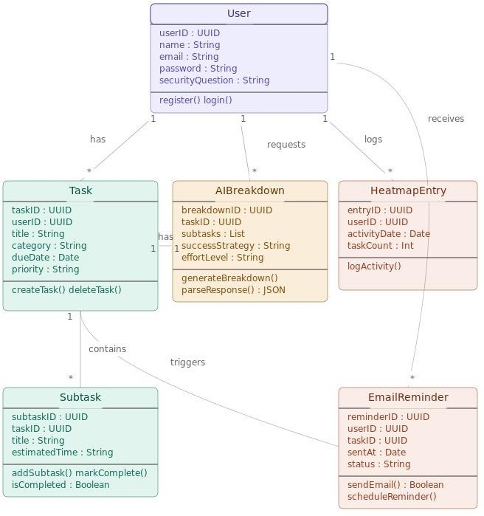
Figure 2 Class Diagram for user of Tasklytics

The class diagram shown in Figure 2, This diagram shows the architecture and interrelation of the basic elements included in the Tasklytics, such as the User, Ta sk, AIBreakdown, Subtask, HeatmapEntry, and EmailReminder classes. These basic classes contain certain attributes and operations which make up their respective responsibility in the system. For instance, the User class will be involved in managing all issues related to user registration and authentication. Likewise, the Task class is responsible for the management of tasks. Additionally, the AIBreakdown class uses artificial intelligence to generate various subtasks, effort estimations, and productivity advice that helps in managing complicated tasks. The other classes include the Subtask which helps break down tasks, the HeatmapEntry which collects activity information to be used in creating productivity heatmaps like on GitHub.

Moreover, it is evident from the diagram how these objects interrelate, based on the practical workflow of the application. One particular User may create and manage many different Tasks, ask for many AI Breakdowns, receive many Email Reminders, and create many Heatmap Entries, showing that it is all about one-to-many relations. Moreover, one Task may include many Subtasks, which allows managing tasks hierarchically, while the AIBreakdown object remains tightly associated with tasks in order to facilitate intelligent planning. By distributing responsibility among classes and making sure that each of them is responsible for a specific aspect of functionality, the designer made the system more modular, easy to maintain, and scalable. In this way, the created class diagram may be used as the basis for backend development

5.2 Use Case Diagram
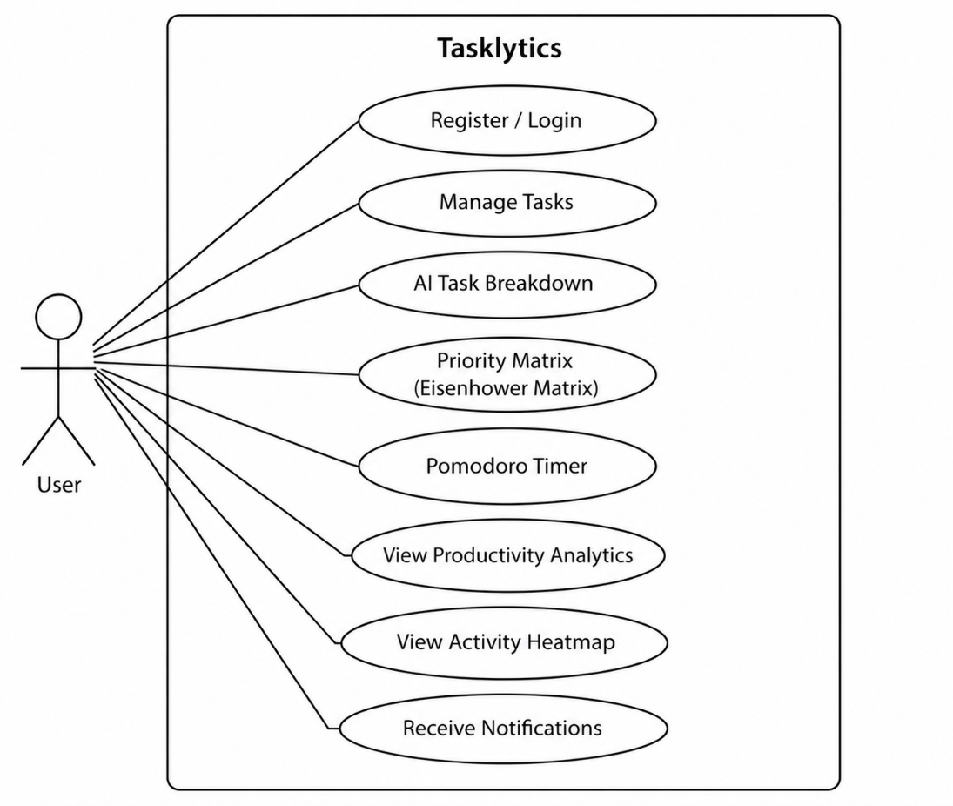
Figure 3 System Use Case Diagram for Tasklytics
Figure 1 illustrates the use case diagram of the Tasklytics productivity management system. The diagram depicts the interactions between the primary actor, the User, and the core functionalities provided by the platform. The user can register and log in to the system, manage tasks, utilize the AI Task Breakdown module to divide complex tasks into smaller actionable subtasks, and organize work using the Priority Matrix based on urgency and importance.
The system also provides a Pomodoro Timer to support focused work sessions and improve time management. Users can monitor their performance through Productivity Analytics and a GitHub-style Activity Heatmap, which visually represents task completion patterns and productivity trends over time. Additionally, the platform delivers notifications and reminders to help users stay informed about upcoming deadlines and important tasks.
The use case diagram provides a high-level representation of the major services offered by Tasklytics and demonstrates how these features collectively assist users in improving productivity, organizing workloads efficiently, and achieving their personal or professional goals.
.

IMPLEMENTATION

6.1 Technology Used

The AI-Powered Student Task Management System uses a three-tier architecture with React.js in the front end, Node.js/Express.js at the back end, and MySQL database, along with Google Gemini 2.5 Flash API that acts as the AI service. In this part, we will discuss the technologies used in the AI-Powered Student Task Management System as well as the various modules that make up the system, not just describing the functionality of each technology or module in isolation but also detailing how they work together.

6.1.1 System Architecture Overview
This system employs a client-server architecture where the client and server components are deployed independently while communicating through RESTful API layer. The client is made using React.js and is a pure browser-based application with all its logic residing in the browser. It renders the UI, manages the state, and sends HTTP requests to the backend. At the backend, Express.js server handles those requests, implements the necessary business logic, talks with MySQL database to store/retrieve data persistently, and returns responses in JSON format. In case the request requires the help of any AI-powered features, then the Express.js server makes a call to Google Gemini 2.5 Flash API.

6.1.2 Frontend Technologies
React.js serves as the basis of the frontend. The whole UI is implemented in the form of Single Page Application, i.e., only the application itself is downloaded in the browser and further page loading is accomplished by navigation through SPA pages. React allows implementing each page of the app — dashboard, task manager, Eisenhower Matrix, and analysis page — as an isolated component with independent internal state and rendering logic, resulting in immediate responses to user input.

React Router implements navigation within SPA. The routes are secured using a custom guard component that performs authorization based on the JWT token and redirects unauthorized users to the login page.

For visualization of productivity analytics charts, Recharts library is utilized. Line charts and bar charts showing such metrics as progress of task completion, workload of each task category, or effort breakdown of tasks in a selected period are displayed as dynamic charts generated according to data obtained from the server.

6.1.3 Authentication & Sessions
Users' identities are handled through JSON Web Tokens (JWT). Upon receiving correct credentials, the backend server verifies the credentials against the database and, if verified successfully, creates a new JWT, signing it with a secret key defined as an environmental variable. The token is returned back to the client, where it gets saved in the local storage. Every subsequent request sent by the frontend includes the saved token within the Authorization header. On the backend, a custom-made Express middleware function processes all requests for secured routes and verifies whether the token's signature and expiration date have not been tampered with before the handler of the corresponding route receives the request. In case of failure, the middleware sends an HTTP status code 401 - 'Unauthorised'.

The users' passwords are never saved in plain text. In the registration procedure, the password passed along with other credentials goes through bcrypt, which is a crypto library implementing hashing with salting and several hashing rounds to be then saved in the database. Bcrypt performs a comparison during authentication without having access to the actual plain text password.

6.1.4 Backend and API Layer
The backend utilizes Node.js and Express.js frameworks. Node.js offers the runtime environment that runs JavaScript on the server using event-driven and non-blocking I/O architecture optimized for concurrency in serving multiple API requests. Express.js supplies the routing framework used to organize all API routes.

The backend is organized into separate folders according to the modular MVC-like architecture with routes, controllers, services, and middleware isolated in their respective folders. Routes file contains URL paths and HTTP methods associated with a feature module (e.g., /api/tasks). The controller function processes the request and calls the related service function to process the actual logic and prepare the output response. Thus, the modification of database logic does not affect routes and vice versa.

Each system operation is available via RESTful API endpoints such as registering/logging in the user, performing CRUD operations on tasks and subtasks, making requests to get tasks broken down by the AI, aggregating analytics data, and managing user settings. All endpoint responses contain the structured JSON payload with standard status codes and structured error messages handled globally.

6.1.5 Database Layer
MySQL 8.0 acts as the relational database management system and runs on Aiven Cloud for reliable access and automatic backup. The database schema is normalised and comprises several tables: users, tasks, subtasks, security questions and user settings, all linked by appropriate foreign key relationships. For instance, when a particular task is removed from the database, all its subtasks are also removed via cascading delete operation.

A pool of existing connections maintained between the backend and MySQL database is established by means of mysql2 driver in Node.js. Instead of creating and destroying a new connection every time an API call occurs (an approach that can lead to performance issues), a pool of connections reuses already open connections, thus improving speed.

Commonly used fields (e.g., user_id, due_date, and status) are indexed for better performance with queries involving sorting or searching tasks.

6.1.6 AI Integration
Task decomposition using AI functionality is carried out via the Google Gemini 2.5 Flash API. The process starts when the user requests an AI-driven task decomposition. In response to this request, the backend builds a structured request including the title of the task, the task description, and the category of the course. This request is then sent to the AI API endpoint via an HTTPS POST request. The AI decomposes the request into four to six subtasks that are logically ordered, together with an estimated time required to complete each task. Moreover, the user gets a personalized approach on how to study the course and how difficult it is in terms of time needed to learn.

The backend analyzes the returned response from the Gemini AI API, and saves generated tasks in the database, ready to show them to the user. Due to the fact that using an external API introduces extra delays and failures, the system implements timeouts and failsafe functionality. If the Gemini API does not return the data on time or the API response cannot be analyzed due to errors, the backend builds the default list of subtasks depending on the course category.

6.1.7 Background Services and Email Notification
The automated notification system is developed as a node-cron job that executes once daily from the backend server. It checks the database for all the tasks that have a deadline set for the following day and fetches the corresponding email address of those users. Then it sends a formatted HTML mail via Nodemailer, which is an SMTP-based email sending library, that contains the task name, category of the course, deadline, and a call-to-action. No SMTP credentials are hard-coded into the source code and they are only kept in the environment variables.

6.1.8 Deployment and Environment Setup
The React-based frontend app is deployed through Vercel, where static content delivery is facilitated via CDN and HTTPS support comes automatically; the latter occurs every time a push occurs in the primary Git branch. The backend is powered by an Express.js application running on Node.js and is hosted on Render, a cloud computing environment that allows for deploying the app as a persistent web service. MySQL database is hosted through Aiven Cloud, which automatically performs backups and connection encryption.

All sensitive data required for successful operation, such as the JWT secret, the key for the Gemini API, the MySQL connection URI, and SMTP settings, are stored in environment variables on each of the hosting platforms separately, thus ensuring their absence from the codebase altogether.

6.2 Screenshots

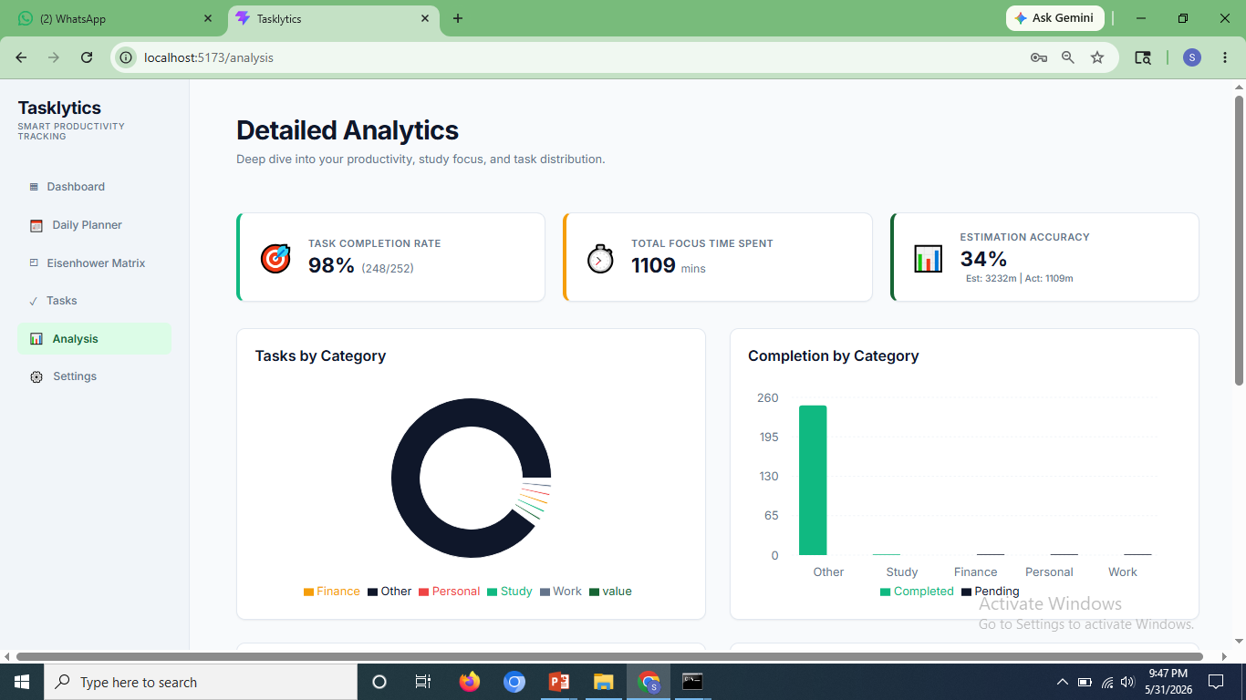
Figure 4 Analytics Page in Tasklytics-1
The page in Figure 4 shows the performance indicators task completion rate, total focus time spent and estimation accuracy and charts like task by category and compleion by category

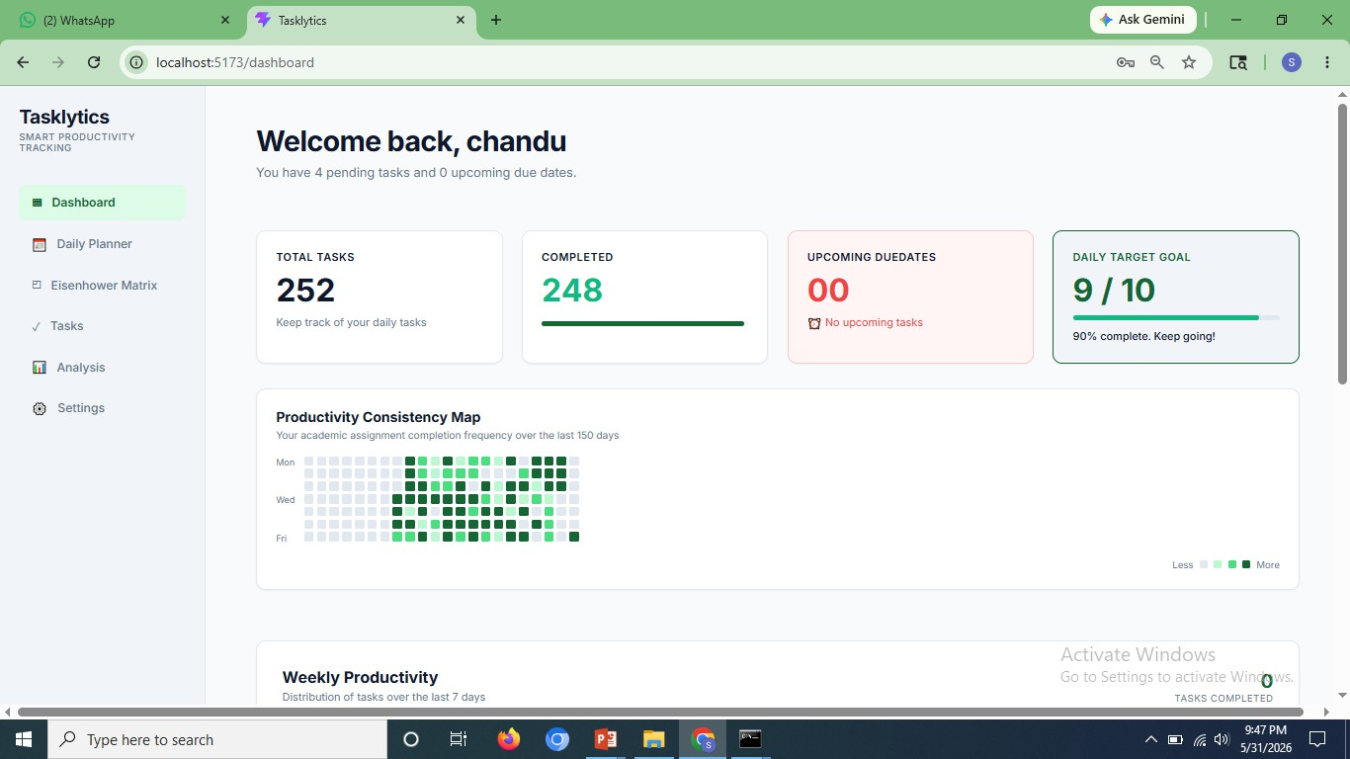
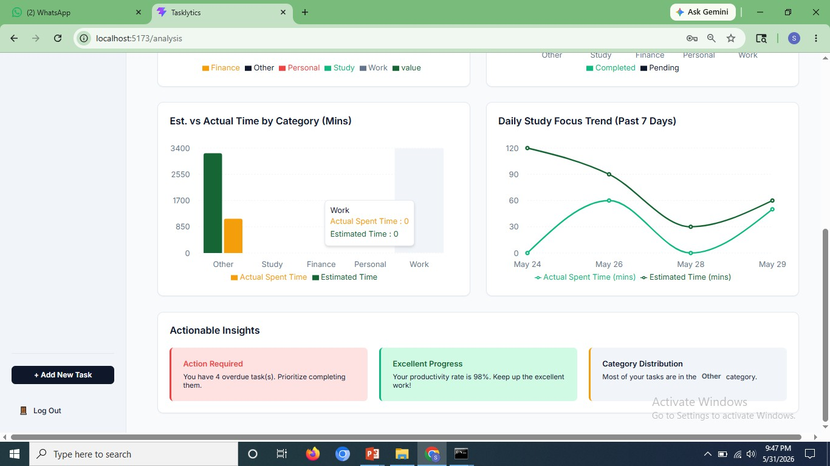
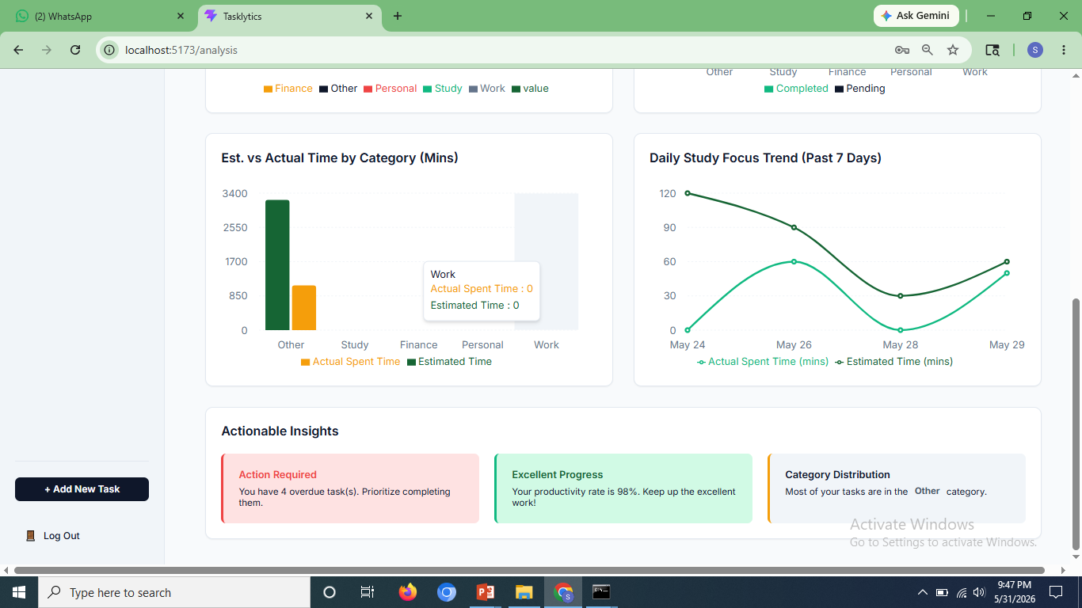
Figure 5 Analytics Page in Tasklytics-2
In Figure 5 we have two other graphs which follow the Analysis page. In the grouped bar graph "Est. vs Actual Time by Category (Mins)," there is a tooltip at work category where Actual Spent Time is 0 and Estimated Time is 0. Another graph is the line graph which shows daily study focus trend (past 7 days). This graph has plotted the actual and estimated time from 24 May to 29 May. Under the graphs, there are three actionable insights' cards. These cards include an alert about "Action required" with four overdue task and a card of "excellent progress" with a productivity rate of 98%.
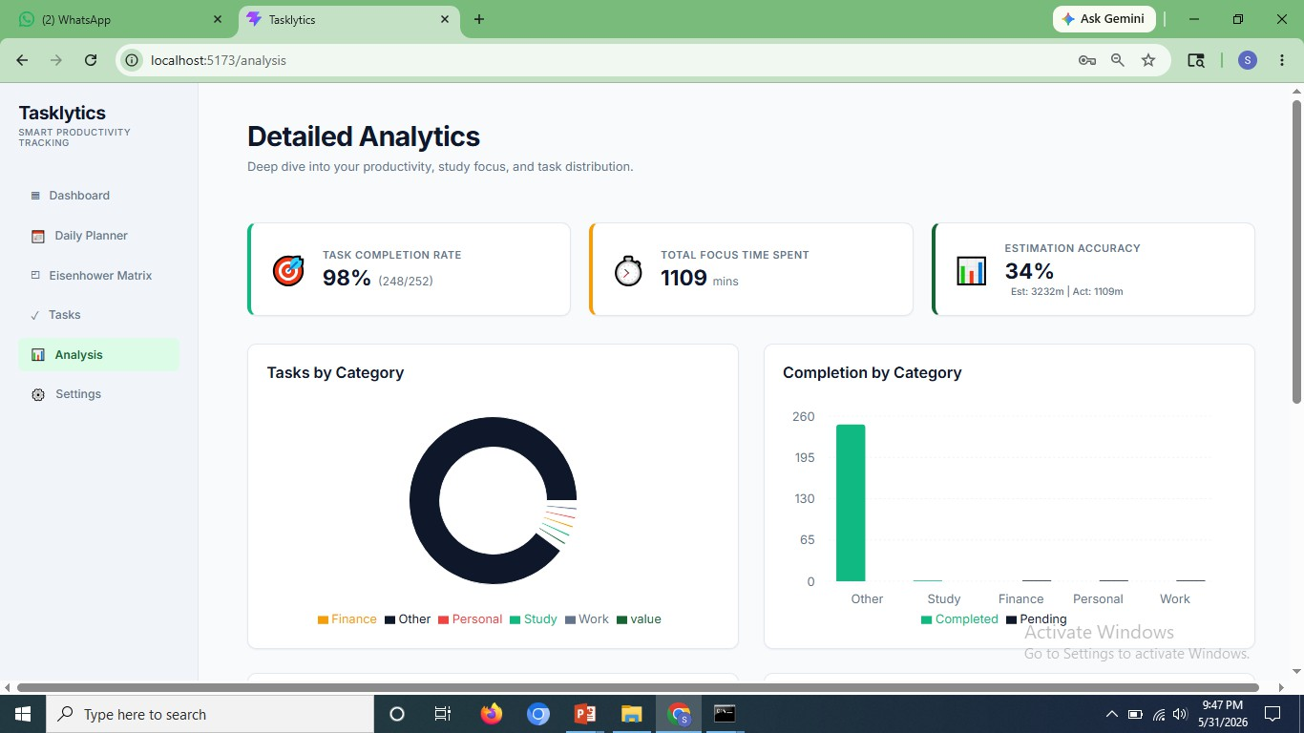
Figure 6 Dashboard of Tasklytics

In Figure 6, the dashboard greets the logged-in user by the name “chandu” and also indicates four pending tasks and zero due dates. Four cards appear showing “Total Tasks” (252), “Completed” (248), “Upcoming Due Dates” (00 - No upcoming tasks), and “Daily Target Goal” (9/10 - 90% completed). Below these cards is shown a “Productivity Consistency Map” which displays productivity on the basis of frequency of task completion within the last 150 days in a heat map format. The weekly productivity starts from there.

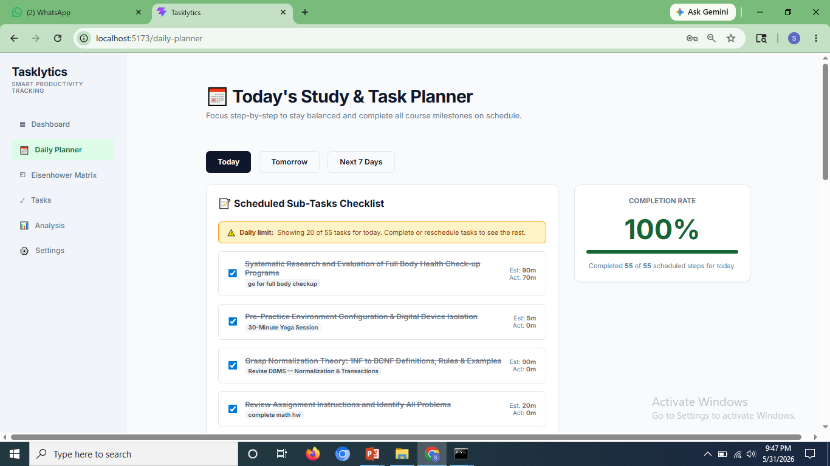
Figure 7 Task Planner in Tasklytics
In Figure 7, Title of the Daily Planner page is "Today's Study & Task Planner" which says "Focus step-by-step to stay balanced and accomplish all course objectives on time." There are three tabs available such as Today, Tomorrow and Next 7 Days. The Today tab displays a "Scheduled Sub-tasks Checklist" with a daily limitation warning (20 out of 55). Many accomplished tasks can be seen with the help of strikethrough words, some of which include "Systematic Research and Evaluation of Full Body Health Check-up Programs" (Estimated: 90m, Actual: 70m), "Environment Preparation and Isolation of Digital Device(s)" (Estimated: 5m) and academic tasks such as DBMS normalization and math homework. On the right hand side, there is a Completion Rate showing 100%, meaning that all 55 scheduled tasks have been completed for today.
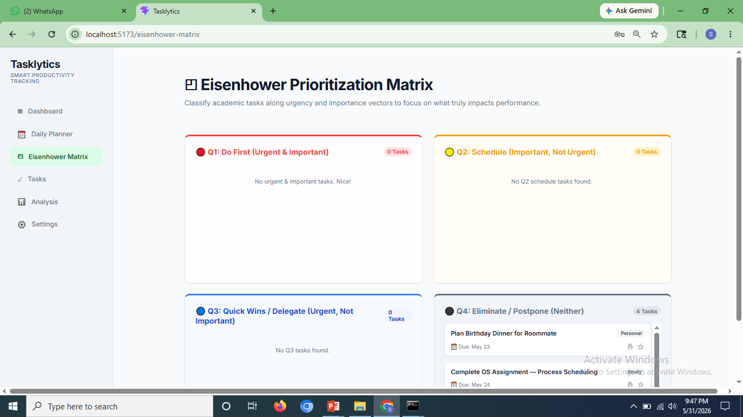
Figure 8 Prioritization Matrix in Tasklytics
In Figure 8, the page arranges the tasks under four quadrants that depend on urgency and importance. The first quadrant is known as Do First, and its description is Urgent & Important. This quadrant currently has no task and displays “No urgent & important tasks. Nice!” The second quadrant is called Schedule because its description includes Important, but not urgent (orange border), and it has no task. The third quadrant has the description Urgent, but not important (blue border). It also has no task. The fourth quadrant has a dark border and shows 4 tasks.
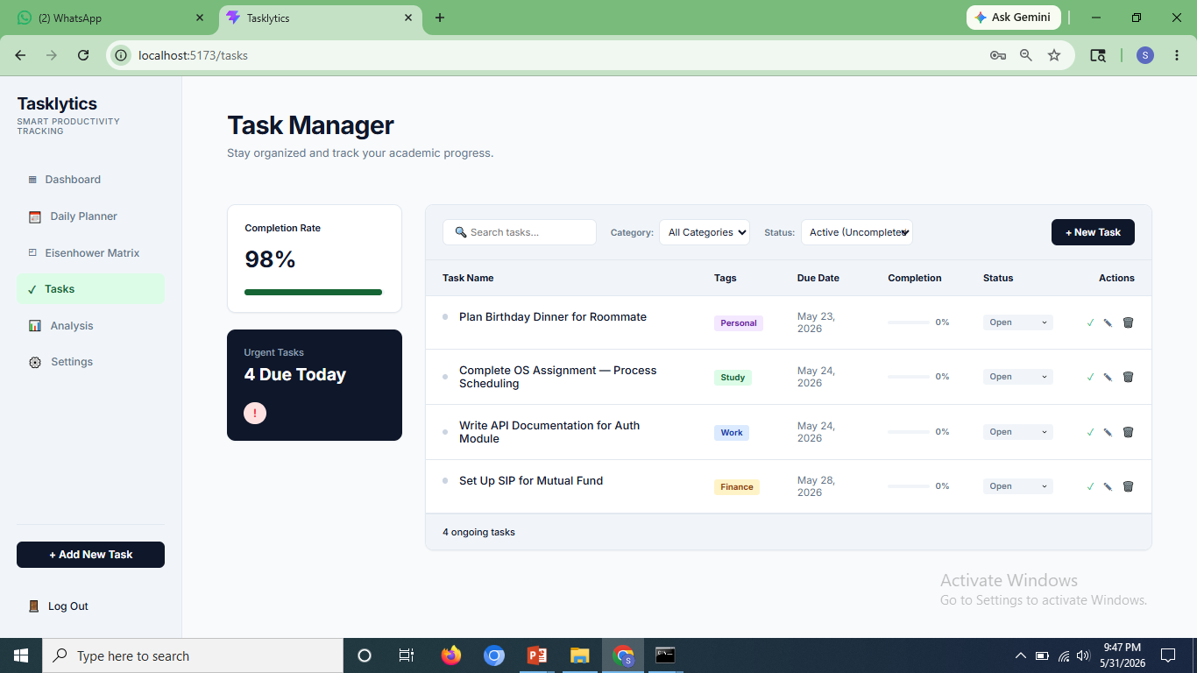
Figure 9 Task Manager in Tasklytics
In Figure 9, In the Task Manager page, users can organize and monitor their tasks. There is a sidebar where the completion rate is noted as 98%, and there is an "Urgent Tasks" banner that mentions 4 urgent tasks which need to be completed today. There is a task listing section where all the tasks can be filtered using Category and Status. There are four ongoing (not completed) tasks listed in a tabular form under the following headings: Task Name, Tags, Deadline, Completion %, Status, and Actions. These are: Plan Birthday Dinner for Roommate (Personal, May 23), Complete OS Assignment — Process Scheduling (Study, May 24), Write API Documentation for Auth Module (Work, May 24), and Set up SIP for Mutual Fund (Finance, May 28).

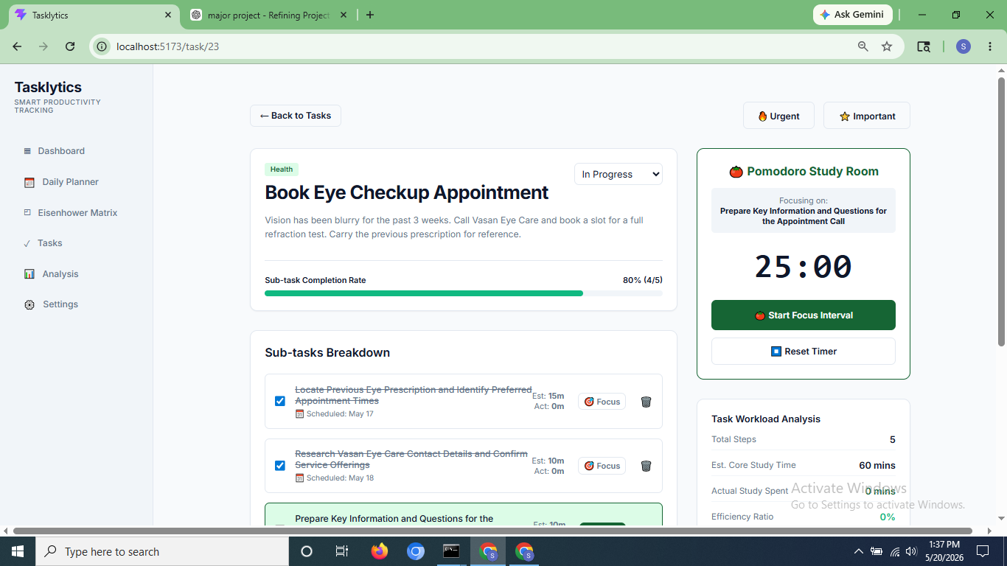
Figure 10 Page of Task Book Eye Checkup Appointment
In Figure 10, the Task Detail Page of the task “Book Eye Checkup Appointment” (URL: /task/23), which is classified under Health and tagged as Urgent and Important, reveals that the task is currently “In Progress,” requiring the user to contact Vasan Eye Care Clinic to schedule an appointment for refraction check-up test. Its sub-tasks' completion percentage is 80%, represented by the completion bar, where the remaining 20% refers to the unfinished sub-task, namely, "Prepare Key Information and Questions for the Appointment Call." In the Sub-tasks Breakdown section, four sub-tasks have already been completed – find the prescription made earlier and get some information about the eye clinic. On the right, there is a Pomodoro Study Room where its countdown timer shows 25:00, reflecting the active sub-task, with Start and Reset buttons provided. Below, the Task Workload Analysis shows that there are five total steps, 60 minutes study time estimate, no actual time spent, and 0% efficiency level.

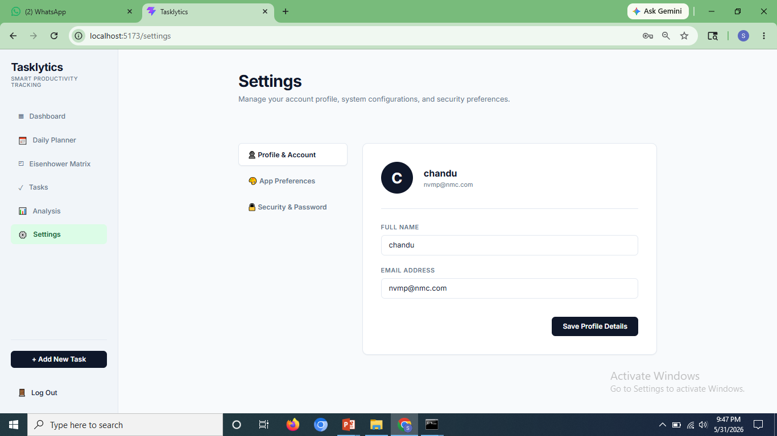
Figure 11 Settings Page in Tasklyics
In Figure 11, Settings is divided into three sections through the left tabs bar: Profile & Account, Application Preferences, and Security & Password. The Profile & Account tab is currently selected and displays the profile picture of the user with initial C, the username as chandu, and email address nvmp@nmc.com. There are options to edit the fields Full Name and Email Address along with Save Profile Details.

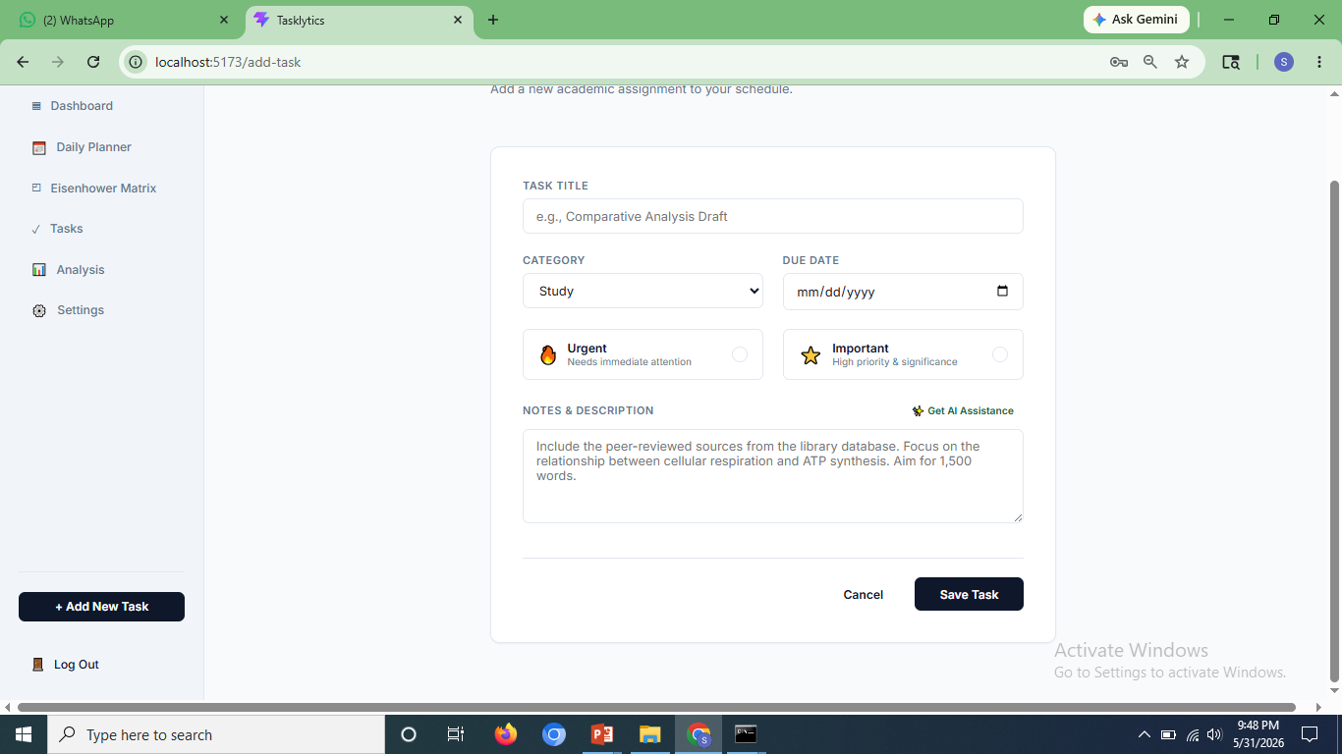
Figure 12 Add New Task Page in Tasklyics
In Figure 12, in the form for adding a task, users are provided with the ability to create an academic task. Form fields are “Task Title” (with placeholder text – “e.g., Comparative Analysis Draft”), “Category” (drop-down field with default value – “Study”), and “Due Date” (date picker). The following two toggles can be checked if the task is urgent (requires immediate action) or important (high priority/level of significance). The placeholder for “Notes & Description” text area describes the research task. The “Get AI Assistance” button is located next to the description label.

TESTING
Testing plays an important role in the implementation stage of software systems since it checks whether the developed system performs as expected under different scenarios. Testing of the AI-Powered Student Task Management System involved testing of the individual modules using a set of predetermined test cases per module. The test cases included information on the description, the input values, the expected response from the system, the real result obtained, and finally, the pass/fail judgment. In case a test case fails, a necessary correction would be made and tested again as another entry. The test results for each module follow as discussed below.

7.1 User Registration and Login Module
The User Registration & Login module acts as the security barrier around the entire application. To use the Task Management features and the AI components, the user has to first register themselves and then log in. Hence, this module underwent extensive testing, which included tests for both the happy paths (valid registration and login), as well as various scenarios that fall outside the scope of a happy path – such as duplicate email registration, incomplete form filling, wrong credentials, and accessing restricted routes without a token.
Table 6 Test Cases for User Registration and Login Module of Tasklyics
Test ID | Test Case Description | Input | Expected Result | Actual Output | Status
TC-001 | Register with valid inputs | Valid name, email, password | Account should be created | Account created successfully | PASS
TC-002 | Register with existing email | Duplicate email | Show "Email already exists" error | Error displayed correctly | PASS
TC-003 | Login with valid credentials | Correct email and password | User logged in and redirected to dashboard | Redirected to dashboard | PASS
TC-004 | Login with wrong password | Valid email, wrong password | Show "Invalid credentials" message | Error message shown | PASS
TC-005 | Access protected page without login | No token | Redirect to login page | Redirected as expected | PASS
TC-006 | Register with invalid email format | Name, invalid email (e.g., user@com) | Show "Invalid email format" error | Error message shown | PASS
TC-007 | Login with unregistered email | Unregistered email, any password | Show "User not found" error | Error message shown | PASS
TC-008 | Registration with missing required fields | Missing password | Show "Password is required" error | No error, registration allowed | FAIL
TC-008a | (Fix) Validation added for missing fields | Missing password | Show "Password is required" error | Error message shown | PASS
TC-009 | Login with empty email and password | Blank email and password | Show "Please fill in all fields" error | Error shown correctly | PASS

In table 6, one such issue detected was during the test case TC-008, wherein the system did not prevent registration despite leaving the password field blank, thus revealing the absence of validation on the server-side. Validation was added to the registration controller to resolve this problem, and the test was re-done in TC-008a. All other test cases went through successfully without any corrections being needed.

7.2 Task Management Module
Correct functioning of the Task Management module is critical for the whole system operation, since errors in the implementation of the module will lead to overall failure of the system operation. Thus, during testing of the task management module, all actions associated with creating tasks, retrieving tasks, applying filters, changing, and deleting tasks were checked, including edge scenarios related to incomplete forms and unauthorized access to data from another user account.
Table 7 Test Cases for Task Management Module of Tasklyics
Test ID | Test Case Description | Input | Expected Result | Actual Output | Status
TC-011 | Add task with valid inputs | Valid title, category, due date, priority | Task created and shown in list | Task added successfully | PASS
TC-012 | Add task with missing title | Empty title field | Show "Title is required" error | Error message shown | PASS
TC-013 | Filter tasks by category | Select course category | Only tasks of that category displayed | Filtered correctly | PASS
TC-014 | Filter tasks by priority | Select "High" priority | Only high-priority tasks shown | Tasks filtered correctly | PASS
TC-015 | Edit an existing task | Update title and due date | Task updated and reflected in list | Task updated successfully | PASS
TC-016 | Delete a task | Click delete on a task | Task removed from list | Task deleted successfully | PASS
TC-017 | View task with no matching filter | Apply filter with no matches | Show "No tasks found" message | No tasks message displayed | PASS
TC-018 | Access another user's task | Different user ID in request | Return 404 or unauthorized error | Unauthorized error returned | PASS
In table 7, test case TC-018 was of special concern which ensured that a user could not access or change task data created by someone else. The server response was unauthorized in this situation, so the task management code implemented using JWT to check ownership of data worked properly. All test cases associated with this module were successful.

7.3 Subtask and AI Breakdown Module
These two features relate to each other in that both the manually created subtasks and the automatically generated subtasks using the AI use the same underlying data storage mechanism and are shown to the user in the same Task Details page.
Table 8 Test Cases for Subtask and AI Breakdown Module of Tasklyics
Test ID | Test Case Description | Input | Expected Result | Actual Output | Status
TC-019 | Add subtask to a task | Valid subtask title and time | Subtask saved and displayed | Subtask added successfully | PASS
TC-020 | Mark subtask as complete | Click complete checkbox | Subtask marked complete | Status updated correctly | PASS
TC-021 | Delete a subtask | Click delete on subtask | Subtask removed from list | Subtask deleted successfully | PASS
TC-022 | Generate AI breakdown with valid task | Task with title, description, category | 4–6 subtasks, tip, and effort level returned | AI breakdown displayed correctly | PASS
TC-023 | Generate AI breakdown with missing description | Task with title only | Breakdown generated using available fields | Breakdown returned with defaults | PASS
TC-024 | AI breakdown with API unavailable | Gemini API key absent | Fallback subtasks returned | Default subtasks shown | PASS

In table 8 the manual subtask test cases — TC-019 to TC-021 — ensured that subtasks could be added, marked as done, and deleted without any impact on the parent task. In addition, the tests for the automatic task breakdown functionality considered three different situations: a valid task where all required fields are filled (TC-022), an invalid task where only the title field is filled (TC-023), and a situation when the Gemini API is not available due to missing API keys (TC-024). In all three cases, the application behaves in accordance with the requirements, and in particular, the fallback procedure in case of missing API keys works flawlessly.

7.4 Daily Planner Module
The Daily Planner is designed to have a focused scope and displays only those tasks that are to be done on the particular day selected by the user. For testing purposes, this feature was tested against three possible conditions: a user having subtasks assigned to today, a user marking a subtask done right from the planner view, and a user without any subtasks planned for today. The three tests were all successful, which proves that the filtering mechanism for selecting subtasks is correct, and the empty view works as intended.
Table 9 Test Cases for Daily Planner Module of Tasklyics
Test ID | Test Case Description | Input | Expected Result | Actual Output | Status
TC-025 | View daily subtasks for current date | Logged-in user | Subtasks due today displayed | Correct subtasks shown | PASS
TC-026 | Mark daily subtask complete from planner | Click complete | Subtask status updated | Status updated correctly | PASS
TC-027 | View planner with no tasks due today | No subtasks scheduled | Show "No tasks for today" message | Message displayed correctly | PASS

7.5 Analytics and Heatmap Module
The Analytics & Heatmap module provides visual interpretation of task data, and its functionality relies upon aggregation queries being correctly written in the database side as well as proper rendering mechanisms on the front end side. In table 10, a total of three tests were conducted for the module: test with a user who had task data already to check that graphs would render with the right data; test with a user who already completed his/her tasks to confirm that heat map shows correct density; and test with a newly registered user who did not have any task data yet to ensure that the dashboard will render properly with the empty state without crashing or showing erroring graph components.
Table 10 Test Cases for Analytics and Heatmap Module of Tasklyics
Test ID | Test Case Description | Input | Expected Result | Actual Output | Status
TC-028 | Load analytics dashboard | Logged-in user with tasks | Charts render with correct data | Charts displayed correctly | PASS
TC-029 | View heatmap with activity | User with completed tasks | Activity grid shows correct density | Heatmap rendered correctly | PASS
TC-030 | View analytics with no tasks | New user with no data | Show empty state or zero values | Empty state shown correctly | PASS

7.6 User Profile and Settings Module
Settings module handles account-related actions such as modification of profiles, changing passwords, and management of security questions by users. Test procedures included successful modification attempts and invalid inputs, where a wrong password was entered while trying to change the password. TC-037 ensured that the system does not approve the modification of the password and responds with a meaningful error message. Five test cases were performed within this module, all of which resulted in passing.
Table 11 Test Cases for User Profile and Settings Module
Test ID | Test Case Description | Input | Expected Result | Actual Output | Status
TC-034 | View user profile | Logged-in user | Show name, email, and profile details | Profile displayed correctly | PASS
TC-035 | Update profile information | Edit form and submit | Info updated and reflected | Profile updated successfully | PASS
TC-036 | Change password with correct old password | Old + new password | Password updated successfully | Password changed | PASS
TC-037 | Change password with incorrect old password | Wrong old password | Show "Current password incorrect" error | Error message shown | PASS
TC-038 | Update security question | New question and answer | Security question updated | Updated successfully | PASS

7.7 Summary of Test Results

For all the seven modules, a total of 38 test cases were conducted, out of which there is 1 re-test due to a change in correction. Out of these test cases, 37 passed upon their initial attempt. There was only one test case failure, i.e., Test Case-008, where it was found that there is no validation done on the password box at the server side when the user signs up for registration. This bug was fixed by applying the validation condition in the registration controller, and the corrected functionality was tested again in TC-008a.

IMPACT ON SOCIETY AND ENVIRONMENT

8.1 Impact on Society

Tasklytic makes a considerable impact on improving how students organize and handle their student responsibilities. Thanks to having a smart and easy-to-use digital tool, it allows students to make better judgments about their learning styles and time management. By including elements like AI task breaks, personalized success plans, a daily planner, and deadline alerts, studying becomes easier for those individuals who find it difficult to organize themselves and cannot afford student coaching or tutoring.

The platform also encourages the emerging culture of self-improvement and study wellness by introducing structured planning, regular efforts tracking, and workload awareness. Through the use of tools like an Eisenhower Matrix and productivity heatmap, students gain insight into their priorities and study behavior, developing good habits in the process. Moreover, through the centralization of tasks and smart recommendations, it minimizes student stress caused by deadline fears.

Overall, on a wider scale, the project showcases the potential of AI technology as far as its democratization is concerned, which means making effective use of it in educational settings despite the lack of expensive institutional infrastructures required to do so. Regardless of their social status, students may benefit from the same level of student planning with the help of AI as they would pay for when using productivity software or getting private tutoring sessions.

8.2 Impact on Environment

While digital platforms tend to have a more minimal direct impact on the environment than physical infrastructure, environmental consequences related to cloud computing in supporting web applications should not be overlooked either. Tasklytic's complete transition from traditional methods of planning tasks and organizing work by removing printed planners, old-school to-do sheets, and study organizers contributes to minimizing the usage of paper products.

In addition to this, Tasklytic's reminder feature eliminates the use of print-out reminder sheets, as well as replacing the necessity of having a physical notice board. Cloud-based implementation of the application using third-party platforms like Vercel reduces the need for maintaining energy-intensive on-premise servers, as the serverless solution only utilizes computational resources when necessary.

Nevertheless, the energy usage related to making API calls and using services of a large-scale language model like Google Gemini cannot be overlooked. To counteract the negative effect of using Google Gemini, Tasklytic utilizes a deterministic fallback mechanism for when the service is down and does not make unnecessary API calls. Prompts are designed to be brief and precise to reduce the number of tokens used.

By advocating for proper digital management of students and by making responsible choices in engineering, Tasklytic acts as an effort to find the balance between convenience, intelligent personalization, and sustainability in education technology software.

8.3 Sustainable Development Goals (SDGs)

Goal 4: Quality Education

Tasklytics is helpful to students and other learners in managing their academic tasks, assignments, projects, and schedules. With the use of the AI Task Breakdown module and Pomodoro timer feature, Tasklytics enables learners to break down academic tasks into smaller tasks and focuses on time management. All this can help in achieving successful educational results.

Contribution:

- Enables effective academic planning and scheduling.
- Facilitates focused learning through time management.
- Helpful in completing assignments and projects successfully.

SDG 8: Decent Work and Economic Growth

The Tasklytics application helps in advancing decent work opportunities and effective work performance since it enables users to manage tasks, organize responsibilities, and achieve better time management skills. The inclusion of features such as the Priority Matrix, Artificial Intelligence Task Breakdown Module, and Pomodoro Timer helps users to organize their work, minimize the likelihood of procrastination, and maintain constant productivity levels. By helping its users perform their duties more effectively, the application contributes towards improving workplace performance.

Contributions:

- Boosts workplace efficiency for users.
- Facilitates better work organization and time management.
- Helps to minimize task overload using intelligent prioritization.
Goal 9 – Industries, Innovation, and Infrastructure

Tasklytics is an example of innovation in terms of integrating web-based technologies and AI technology within a productivity management system. In the case of Tasklytics, the AI Task Breakdown Module facilitates task segmentation into subtasks by users while also offering productivity analytics on user behavior. Tasklytics highlights the capabilities that digital innovations can bring to task management and optimization processes.

Contribution:

- Innovation of AI-based productivity management tools.
- Innovation in personal/professional task management and automation.
- Creation of intelligent infrastructure for workflow optimization.
- Innovation in productivity and project management systems.

Goal 12: Responsible Consumption and Production

Tasklytics supports responsible consumption and production through effective utilization of time and resources. The application assists users in distinguishing between urgent and non-urgent tasks and enables them to make decisions on how to efficiently utilize their time and resources. The user is capable of recognizing any inefficiency and allocating time appropriately without losing time on unnecessary undertakings.

Contributions:

- Ensures efficient utilization of time and resources.
- Decreases losses incurred due to inefficient task planning.
- Supports evidence-based decisions for better resource allocation.

CONCLUSION

Tasklytic's development, which is an AI-assisted student task management platform, was intended to provide a solution that would cater to the shortcomings of generic productivity applications by providing an intelligent, custom-built and performance-oriented platform specifically developed for students. Tasklytic supports students' tasks and subtasks management, generation of task breakdowns with the help of AI technology, visualization of productivity analytics, and deadline reminders, all of which are required by student users to facilitate more efficient completion of academic assignments.

In terms of technical features, Tasklytic uses user authentication, CRUD operation for task and subtasks, AI powered by Google Gemini, daily planner, Eisenhower matrix task prioritization, productivity heatmap, and email reminders using cron jobs. Code reusability and modularity were made possible with the use of React.js and component-driven architecture, whereas the fully responsive web design allowed for the best performance on all types of devices. At the server-side, non-blocking, scalable, and easy-to-maintain server architecture was achieved with the help of Node.js and Express.js, while MySQL offered efficient storage of structured relational data. JWT authentication and well-designed APIs helped protect user's sensitive information, whereas modular routes enhanced the scalability of the application.

Tasklytic has provided an invaluable learning opportunity for full-stack development, RESTful API development, AI API integration, database design, scheduled background tasks, and cloud implementation. Testing has been performed at every stage of the process, including unit testing on each component, testing of APIs using Postman, and integration testing to ensure proper interaction of frontend and backend solutions. This helped in guaranteeing that the system operates seamlessly without any hiccups.

In general, Tasklytic has improved technical competencies within the team and shown that with the correct design approach, intelligent use of features, and engineering, we are able to build a high-quality and scalable solution designed specifically for students' needs.

FUTURE ENHANCEMENTS

Tasklytics can be further enhanced in the following ways:

- Collaborative Study Groups
The development of Collaborative Study Groups will be another great way to enhance the functionality of Tasklytic in the future. Collaborative Study Groups will enable students to complete their assignments, projects, and other learning activities as a group within a common environment. In such groups, users will have an opportunity to assign and manage tasks collectively, divide assignments into sub-tasks, track progress, receive notifications about tasks' completion, and much more.

To organize efficient collaboration, Tasklytic can offer such functionality as role-based access control in which each user will have access to certain features depending on his role within a particular group. For instance, there may be such roles as Group Owner, Editor, and Viewer who will have various permissions and possibilities according to their positions. This feature will allow organizing efficient teamwork and learning process.

Integration with Learning Management Systems (LMS)
Another way to improve the functionality of the Tasklytic system in the future is its ability to be integrated with some Learning Management Systems, including Moodle, Google Classroom, and Canvas. In this case, all assignments, due dates, course announcements, and student academic schedules would automatically be synchronized with the task manager. Students would be able to avoid making manual entries and thus save time and make sure that all academic tasks are timely updated.

With automated synchronization of academic information, Tasklytic could become a dashboard where students have all relevant details regarding their studies. Students could manage various tasks coming from different subjects and courses without any delays since they could rely on automated updates and reminders. Integration with other learning platforms would make it easier for students to stay organized and manage their workload.

Advanced Analytics and Personalised Insights
One possible future enhancement for Tasklytic may involve the incorporation of Advanced Analytics and Performance Insights to allow students to gain further insight into their study techniques. By using advanced analytics to examine the patterns of task completion, studying time, and academic activity, the system could provide subject-based performance trends, week-end productivity summaries.

Not only would these features allow students to benefit from the software but also provide comprehensive reporting capabilities for instructors and universities. The system could potentially incorporate analytics systems such as Google Analytics and create its own dashboards for tracking user activity and platform engagement. This would provide administrators with information needed for data-driven decision making and improvements in student productivity.

11. BIBLIOGRAPHY
- Express.js Foundation. (n.d.). Express Documentation. Retrieved from https://expressjs.com
- React Official Documentation – Meta. (n.d.). React Docs – A JavaScript library for building user interfaces. Retrieved from https://react.dev
- Node.js Documentation – OpenJS Foundation. (n.d.). Node.js Documentation. Retrieved from https://nodejs.org/en/docs
- MySQL Documentation – Oracle Corporation. (n.d.). MySQL 8.0 Reference Manual. Retrieved from https://dev.mysql.com/doc
- mysql2 – npm Registry. (n.d.). mysql2 – Fast MySQL driver for Node.js. Retrieved from https://www.npmjs.com/package/mysql2
- Google Generative AI – Google LLC. (n.d.). Gemini API Documentation. Retrieved from https://ai.google.dev/docs
- Nodemailer – Nodemailer. (n.d.). Nodemailer – Send emails from Node.js. Retrieved from https://nodemailer.com
- node-cron – npm Registry. (n.d.). node-cron – Task scheduler for Node.js. Retrieved from https://www.npmjs.com/package/node-cron
- JSON Web Tokens – Auth0. (n.d.). Introduction to JSON Web Tokens. Retrieved from https://jwt.io/introduction
- bcrypt – npm Registry. (n.d.). bcrypt – Password hashing library for Node.js. Retrieved from https://www.npmjs.com/package/bcrypt
- Vite – Evan You & Vite Contributors. (n.d.). Vite – Next Generation Frontend Tooling.
Retrieved from https://vitejs.dev
- W3Schools – W3Schools.com. (n.d.). HTML, CSS, JavaScript Tutorials. Retrieved from https://www.w3schools.com
- MDN Web Docs – Mozilla Developer Network. (n.d.). Web technology reference. Retrieved from https://developer.mozilla.org
- GitHub – GitHub Inc. (n.d.). Open-source project collaboration and version control. Retrieved from https://github.com
- GeeksforGeeks. (n.d.). Full Stack Development Tutorials and Concepts. Retrieved from https://www.geeksforgeeks.org
- Figma – Figma Inc. (n.d.). Collaborative Interface Design Tool. Used for UI wireframing and prototypes. Retrieved from https://www.figma.com

